**Team Organisation**

It was agreed that the team will not assign a role to a single person, at least not specifically. Normally this can be seen as a drawback, but it increased the friendship between the colleagues. Freedom to choose what to do enhanced the effort that was put in everybody’s work. The leadership was shared between two people as well as the meetings’ organisation, the responsibility for redaction of the journals was rotating through everybody. All the members of the team have tried to share the same amount of responsibility.

It was used two applications for the main purpose of communication and file share. A WhatsApp group was created for messaging, as everyone has this app in their phones then there was no doubt that it will be the best way to communicate quickly and effectively, and it was named “ESP GROUP 22”.

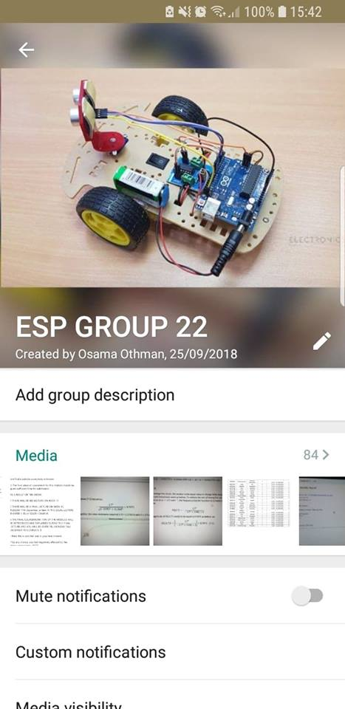

As it can be seen in Figure 3.1 the group was created by Osama Othman on September 24th of 2018 and it was used mainly to establish the days and time of the meeting as well as to answer some questions and/or take simple decisions.

In the same way, a Dropbox folder was created by Marlon Guanoluisa on October 6th of 2018 to share documents, tables and any other related information. Which can be found in the following link:

<https://www.dropbox.com/sh/u3l5d3g69wiv0qz/AABpm1Bbjad1x9BgkFe5X2Kwa?dl=0> .

For keeping an organised and clean place of sharing files, the following simple rules were set:

* Creation of different folders for each topic.
* Upload as soon as possible the work done.
* Check everyone’s documents.
* Create a new document followed by the corresponding version and save it in the same folder that was taken, if a modification was needed.
* Avoid uploading unnecessary content.
* Inform all members what was modified, if any.

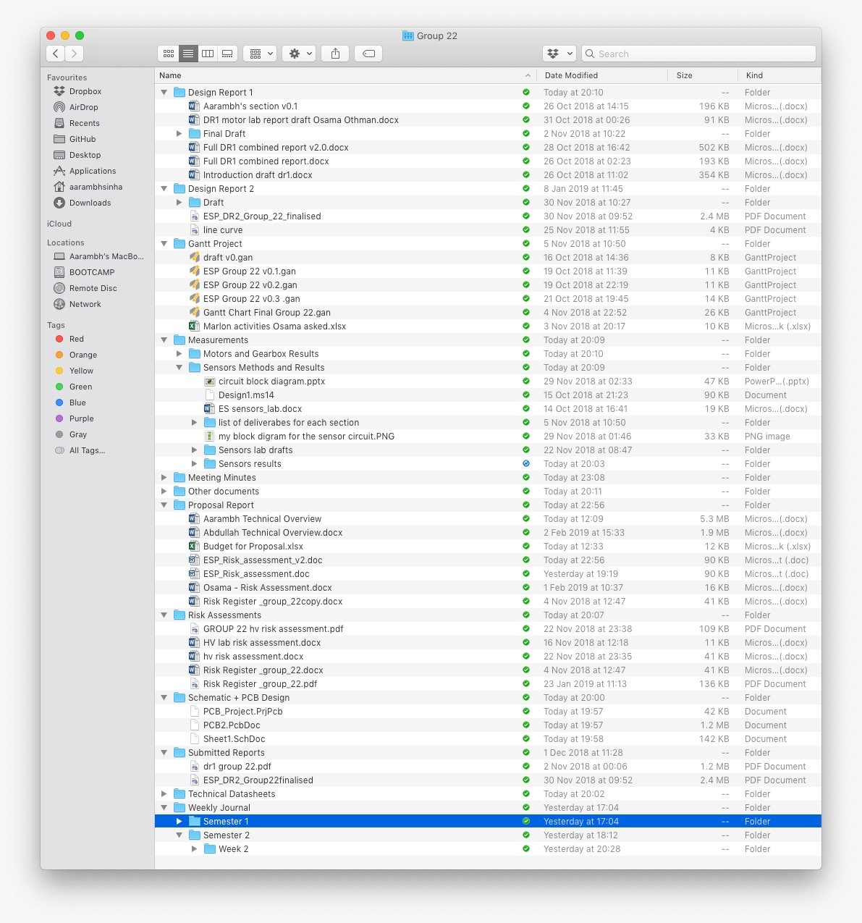

As mentioned before, meetings were informed using the messaging platform WhatsApp and they were carried out at least twice a week. Every Monday after having been discussed with the tutor, the group met for one to two hours approximately on that day, Wednesday and/or Friday were the most usually days used for having another meeting depending on how busy or difficult it was the week. In Dropbox, the previous link, some pictures can be found containing the information discussed on those days in the folder called “Meeting minutes” that was also used as a guide for writing the weekly journal which as well can be found in the folder called “Weekly Journal”.

In a cooperative and relaxed environment, all members of the group were able to share their ideas and participated at the time of deciding. To take a decision, there was not usually any problem, and everybody agreed in one thing, whatever decision made it must be supported by at least 80% of the total number of members i.e. four people. It was encouraged to all colleagues to say any curiosity to make to everyone clear about what are the advantages and disadvantages of taking such decisions. Therefore, no regrets were carried and as well as no blames to anyone.

The work has been tried to be shared in an equal way. Although there is not a manner of giving to each one an exact amount of work, it was assured that everyone take almost the same workload and even when any one of the members was able to finish his work earlier than expected, it was asked to this person to try and help to one of the colleagues that is struggling in doing the task entrusted. Of course, a plan was developed to do not lose the path of the project. Having a plan to follow makes easy for the group to carry out all tasks in an established time. To achieve this the application called “Gantt Chart” was used which it will be seen later in this document and structured for this semester. Considering the learning styles of each one and their individual skills it was concluded that Osama Othman and Subhi Alsous will be working on the software development and Abdullah Ahmed Akhtar, Marlon A. Guanoluisa Pozo and Aarambh Sinha will be focusing on circuit and hardware development. The meetings will continue having a place at least twice a week to check the progress of everyone as well as solving any issue related to the project.